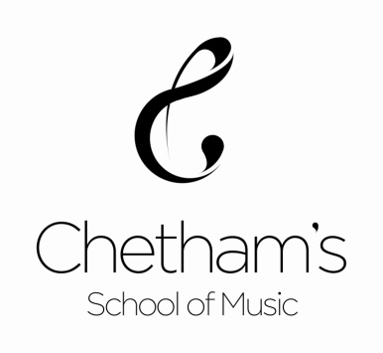

Chetham’s School of Music, Long Millgate, Manchester, M3 1SB T: +44(0)161 834 9644 F: +44(0)161 839 3609 www.chethams.com

PHOTOGRAPHY AND RECORDING PERMISSION FORM
Whole-group authorised signatory
Music in Residence Project Participants October 2018 – March 2019.
Staff and students at your school are taking part in a project led by Chetham’s School of Music Outreach department. We would like to take photographs and collect audio/video material as a record of the project and for use in future publicity. This document records your consent to photography and recording and permissions for usage of this material. By signing this document you confirm that you are authorised to give consent and permission on behalf of all staff and students. Any exclusion or modification must be detailed in the signatory section overleaf. Please read the information below carefully: it describes our usage of media obtained in the project.
Creation, collection and usage essential information
- We may create and collect photographic/audio/video material featuring all staff and students present in the project delivery spaces. This may include the presence of photographers/staff from trusted partner organisations.
- Incidence of photpgraphy and recording include the Music in Residence workshops and CPD sessions at your school (dates as agreed with your school in related emails/discussion, Jan – March 2019) and school concert attendance at Chetham’s School of Music on 1 March 2019.
- We may use the photographic/audio/video material collected in this project in current and/or future publicity, about this project or about Chetham’s School/Outreach generally, in print, on our website and our social media. We may share this material with trusted partner publications/organisations as part of publicity about Chetham’s Outreach in print, press, internet and social media.
- We will not identify participants by name in any publicity.
- We request contact details for permission records only and will only contact you in relation to this event. Your details will be kept in line with data protection procedures and not passed on to any third parties without your consent.
- We will store and use photographs in line with our organisational policies regarding data protection.
TO BE COMPLETED BY AUTHORISED WHOLE-GROUP SIGNATORY

School name*

I give permission for Chetham’s School of Music and/or partners to take photographs, film footage and audio recordings for use as outlined above in relation to the Music in Residence project. I have read the attached Creation, collection and usage essential information.

Signature

Date*

Main Contact Name*

Main contact role*

Main contact telephone number or email*

*Please print clearly

This form must be returned:

- As an original signed hard copy to Chetham’s staff or by post to
Outreach Programme Coordinator
Outreach Department
Chetham’s School of Music
Long Millgate
Manchester M3 1SB
AND
- electronically as a scanned document to: joinin@chethams.com

